General description
I am designing a computer system for a catering service.
The system will allow the staff to create and manage appointments for their clients. (done)
They (the company) only caters to picnics. (don)
Only two things are customizable, the menu choice and the amount of people to be expected.
The system can see future appointments and supplies required for those said appointments.
The idea is to have this system for the companies’ eyes only.
Clients can only book appointments via a receptionist.
Its intention is to make it easier to track appointments and manage them.
The system will allow for fifteen events per week. (done)
The clients have from ten menus to choose from as well as five decoration sets.
The system will display upcoming appointments and require supplies for the delivery team to assess.

Requirements
- Appointments
It shall allow the receptionist to see and make future appointments
It shall for the ability to modify/move the appointments within 48 hours
It shall allow for the cancellation of an appointment
The system shall not allow more than 15 events per week
- Payment system
The system shall require 20% down payment prior to client making appointment
The system shall allow either cash payments or card payments via a third party
The system shall require the rest of the payment to be fulfilled upon delivery
- Information system
The system shall keep track of the required supplies for each event
The receptionist shall be able to log customer information concerning the event booking
The system shall allow the delivery time to see the location and time of each event
The system must link each decoration with its respective picnic set.

Use Cases
Name of use case: | Book an appointment
Actor(s): | Employee, client
Completion | - Client requests appointment  - Employee books appointment  - Client pays down payment and receives event confirmation
Alternatives: | No available time slot for client  Client fails to pay

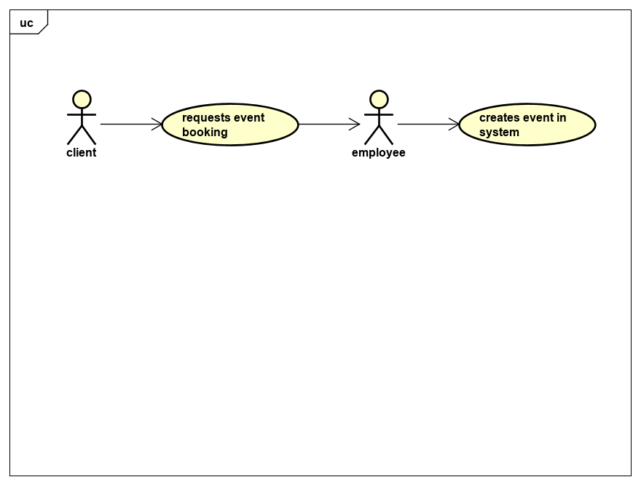

Name of use case: | delivery
Actor(s): | Delivery staff
Completion: | - Check upcoming deliveries for the next three days  - Gather required supplies according to system  - Confirm time/location before going  - Make delivery and collect payment
Alternatives: | There are no deliveries for the next three days

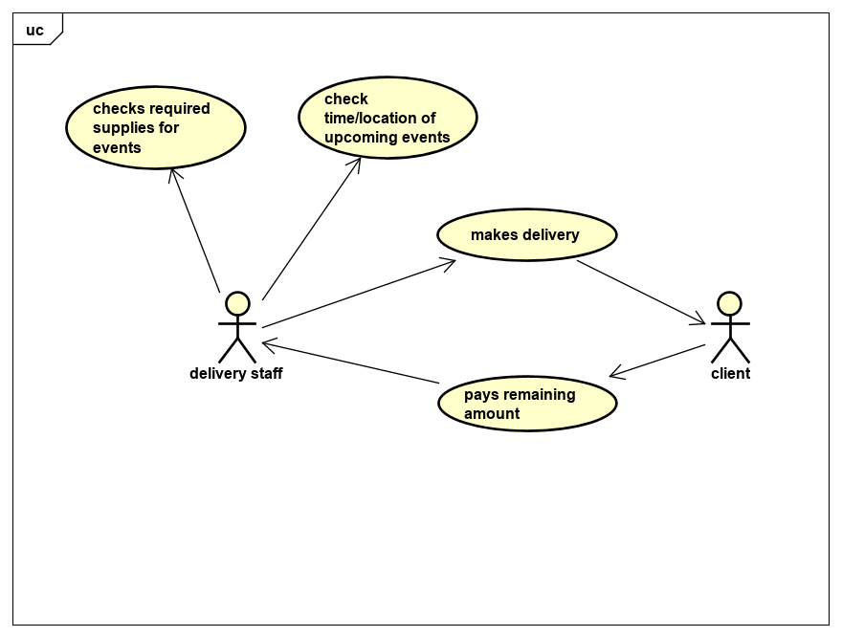

Name of use case: | Cancelling appointment
Actor(s): | Employee, Client
Completion: | - Client desires to cancel event  - Employee verifies their event date.  - Employee cancels appointment
Alternatives: | There is no registered appointment in system  Client waited too long to cancel the booking

